Ahmednagar Jilha Maratha Vidya Prasarak Samaj’s

NEW ARTS, COMMERCE AND SCIENCE COLLEGE , PARNER.



**A**

**Project Report**

**On**

***BANK ACCOUNTING SYSTEM***

**Submitted by**

**Miss.**

***(MASTER OF COMPUTER SCIENCE***

***Semester I)***

**University of Pune 2012-2013**



**INDEX**

1. **Introduction :**
   * **Acknowledgement**

**2. Study of Existing System:**

* **Manual System.**
* **Need of Computerization.**
* **Fact finding Technique.**
* **Problem in Existing System.**
* **Feasibility study**

1. **Proposed System.**

* **Proposed System.**
* **Scope and Objective of Proposed System.**
* **Hardware & Software specification.**

1. **System Design:**

* **Entity Relationship Diagram.**
* **UML Diagram.**
* **Data Dictionary.**
* **Data Structure**
* **Input Design.**
* **Output Design.**

1. **Testing Procedure & Implementation Phase.**

* **System implementation**
* **Program Testing and user acceptance**

1. **User Manual.**
2. **Constraints & Limitations.**
3. **Conclusion.**
4. **Bibliography.**

**1.INTRODUCTION**

**ACKNOWLEDGEMENT**

The project titled “BANK Acountting System” would not have been possible to bring this work to a successful completion without support and guidance of our respectful teachers.

We would like to specially thank Head of Computer Department Prof.

our teacher Prof. for timely help and encouragement of fulfilling of project work.

Finally, we gratefully acknowledge the help provided the Department Of Computer Science at various stages of development of the project. We are also thankful to all our friends for their help and suggestions in completing our project.

“When we start a journey towards something worth while

It’s never a simple trail nor easy mile,

But we often move on without looking back,

Due to all the people who helped & put us on track.”

With Regards . . . ,

Miss..

**2.1**

**MANUAL SYSTEM**

## The present work of the bank control transaction is done manually which can be discussing below:

1. **When any customer comes into the bank to open the account bank gives information about opening the account.**
2. **Bank collect his own information like name, address, age and profession business and after give the permission to opening the account.**
3. **And after open the account they gives fixed account number to the account holder.**
4. **Account holder take the loans form bank then bank collect his information and NODES' of other bank and after that bank sanctions the loan. And collect the interest on that loan amount.**
5. **If holder wants to open the fixed deposit account in the bank. for that, bank give another account number and on that fixed deposit bank.**
6. **Bank also issued shares to the partner of the bank to increased capital.**
7. **Bank made financial report for the each year.**

**2.2**

**NEED OF COMPUTERIZATION**

**Today we are going to face to 21st century. Since, all the activities and operations are carried out manually. There are many problems to do it. Some possibilities are as follows.**

1. **Wastage of manpower.**
2. **Wrong calculations.**
3. **Duplicate work.**
4. **Physically record storage problems.**
5. **Lack of information on time.**

**Important reasons for computerization are:**

1. **Speed - computer are extremely valuable if speed is required in process data greater processing speed, faster information retrieval.**
2. **Quantity - Large amount of data can be processed very quickly.**
3. **Repetitiveness - The more repetitive task, the more practical it is to do.**
4. **Complexity - Problems with several interfacing various can be solved quickly and accurately.**
5. **Accurate Output - Great accuracy can be obtain as needed also accuracy is not affected by boredom and fatigue.**
6. **Exact Output - Computer require input that are exact, judgment is not attribute of the machine**.
7. **Control- Improved consistency and security is achieved.**
8. **Cost - Cost can be reduced by saving manpower.**
9. **Competitive Advantage - Using computer we can quickly generate the report in less time. Computer can store of organizat so strong of files and their maintenance expenses are in floppy, disk or hard disk storage.**

**Through computerization one can keep control on the various information related to deposit system.**

**2.3Fact Finding Techniques**

**While designing the system preliminary investigation is very important and essential one preliminary investigation part has total base system. Whole building of the investigation of the system is depending upon preliminary investigation.**

**Following techniques does it:**

1. **Observation:**

**When I observe the proper flow of the system. I got very important information as well as I understand the current system very well.**

1. **Interviews:**

**Much information is gathered through this process in which much questions are ask to the responsible person. Also clear understanding about there requirement and brief discussion is done with the owner of the agency. Who told me about the current system. The result of this I become much friendlier with the system.**

1. **Questionnaires:**

**To achieve the information I visited the management staff and they have given me the answer of my questions, which help me to understand the proper flow of the system.**

1. **Record review:**

**Also achieve the information is gather by reviewing the past and original document, which gives clear format, style and recording. So I got clear picture about the output document and report format.**

**2.4 PROBLEMS IN EXISTING SYSTEM**

* **The manual firstly involves very boring job of data entry. As and when new customer comes in contact, details must be entered into books. For maintaining, integrity it is always necessary to check for different account numbers for different things. Explaining customers different types of account available, coming soon scheme and at the same time maintaining calculations up to data is a very risky job.**
* **The main problem arises while passbook is generated. Employees have to check the status of the account, current balance at the time of withdrawal etc. due to manual error and lot of working wrong assignment may be done. which will result in loss to the company.**
* **Employees have to draw diff. tables for long calculations. They have to enter day-to-day transactions in those tables. Though the calculator helps them, problem arises when the employees have to take of all balance in reports. Consider the same working of the user to take total as soon as the reports are generated total will be available for next use.**
* **Due to increment facility there is no violation of integrity constraints.**

**2.5. FEASIBILITY STUDY**

**An important outcome of the preliminary investigation is the determination that the prepared system is feasible.**

**There are three aspects in the feasibility study portion of the preliminary investigation.**

1. **Economical feasibility.**
2. **Technical feasibility.**
3. **Operational feasibility.**
   * 1. **2.5.1 Economical Feasibility:-**

**Computerization and automation leads to cost reduction and beneficial to the cost analysis of the system. It yields the following result.**

**a) Training cost is incurred as per the user of the system are not familiar with the software platform. Nevertheless, very less cost is incurred which is affordable by any admission process.**

**b) Automation leads to the reduction of the man power & processing time.**

**c) The cost of purchasing hardware setup is much less than that of cost required for user and maintenance of manual system. The required software is available for the company. The financial benefits arising due to improved readability, accuracy of the reliable & quality information. As a computerized system can**

**Do work of many employees this is one time investment for the college then spending on the employee salary.**

**2.5.2. Technical feasibility:-**

**The technical feasibility is related with H/W, S/W present at company premises, and the S/W uses for the development of the prepared system in Mysql & MS access.**

**For implementing the prepared” Admission system for the degree course**

**2.5.3. Operating feasibility:-**

**Operational feasibility study involves the operation evaluation, Organization impact & development performance etc.**

1. **As the user of the system is trained to use the new environment, they are capable to work on the new system.**
2. **User documentation of the proposed system makes user of the**

**System without error.**

1. **Well documentation of the proposed system gives complete idea**

**About the system design to the user. It also helps in the maintenance of the system.**

1. **The system will provide timely information and status of various**

**Activities top the management. It will fascinate the usage of the system.**

**So the proposed system has the support of the management which recognize for computerization for reliability accuracy in the “Admission system for the degree courses” as well as the need for giving correct reports to management personnel. So the system is operationally feasible.**

**So it can be conclude than the system proposed is economically, technically & feasible.**

**3.PROPOSED SYSTEM**

**3.1 PROPOSED SYSTEM**

* **Bank accounting system is essential in every bank, there are chance to change record by manually working. But it is not possible after system is tally computerized. Cost of doing work by computer system is less than that of manual work. Although the starting cost due to computerization is very high but its speed, efficiency, storage capacity and quickness must be very high. It will help user very much in updating of rewards. It will help to generate the enquiry, withdrawal, deposit, loan and account checking very quickly. The proposed system contains their master entries, transaction entries in which user allow adding, deleting rewards.**
* **Using all files various report are generated. All system should have menu driven so no0 confusion to user. Whatever user want he gets properly through the system. If the user does any incorrect data entry, proper message are displayed on screen. System should be so simple, so that normal user can handle it.**

**3.2**

**SCOPE AND OBJECTIVE OF THE SYSTEM**

**The objective of the work of the system can be summarized as follows.**

**It is possible to print various reports like.**

1. **Maintenance of master files.**
2. **Data entry for various transactions.**
3. **Printing of various reports.**

**For all this clear information and understand should have done regarding to the system the proper documentation should be necessary. Proper normalization and creating of database files should have done properly also various designing should have done.**

**Finally, the system should have tested by tally reports that can give much experience in system development.**

**3.3**

**HARDWARE AND SOFTWARE SPECIFICATION**

**Hardware requirement:**

**“The entire physical equipment i.e. input device processor, output device and interconnecting equipment of computer are called as hardware”**

1. **Pentium VI GHz.**
2. **512 MB RAM.**
3. **80 GB Hard disk.**
4. **Monitor.**
5. **Printer.**



**Software requirements:**

**“The utility programs which are required to drive the hardware of the computer are called software”**

1. **Windows XP.**
2. **Adv. Java.**
3. **Microsoft Access.**

**4.SYSTEM DESIGN**

**3.1 ENTITY RELATIONSHIP DIAGRAM**

**has**

1 1 m

**makes**

**have**

**a/c open**

**for**

**enquiry**

**customer**

1 1 1 m 1

**request to**

**to**

1

**give details**

**a/c type**

1

**user**

**paid**

**has**

m

**withdrawal**

**to**

**has**

1

**installment**

m

**from**

**assign**

**deposit**

1

m

**chequebook**

**loan**

**ISA**

**for**

**ISA**

**spl. saving a/c**

**current**

**unsecured**

**secured**

4.2 UML DIAGRAM

**4.2.1. Activity Diagram:-**

**4.2.2. Class diagram:**

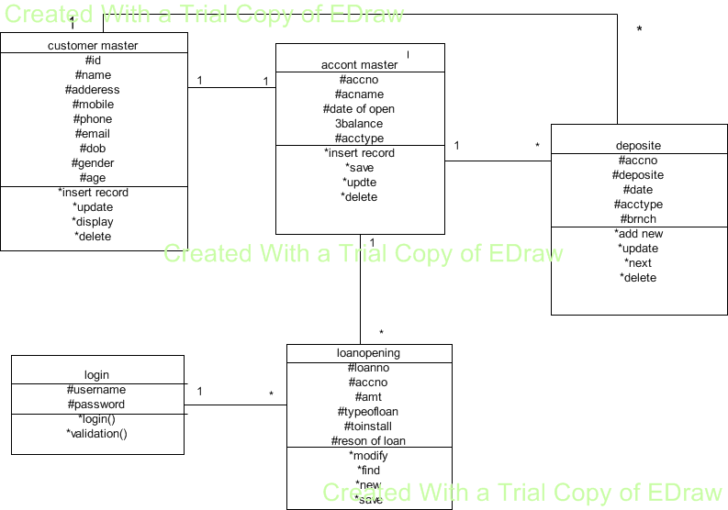

**4.2.3.Withdrawal collaboration digram:**

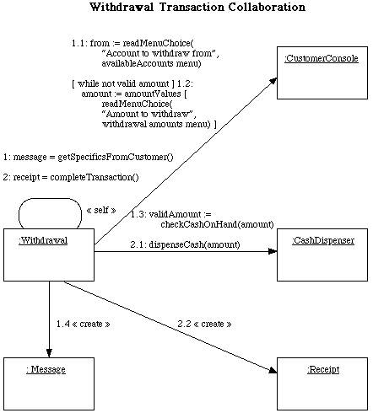

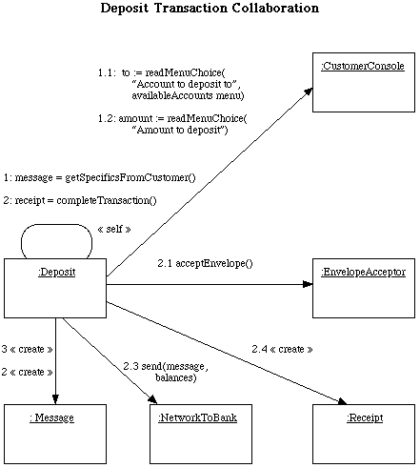

**4.2.4.Inquiry transaction collaboration digram:**

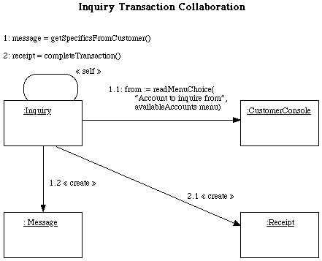

**4.2.4.Transfer transaction collaboration digram:**

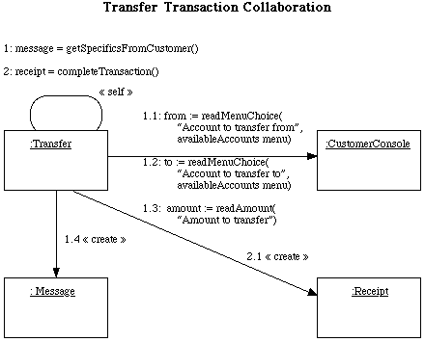

**4.2.5.Deployment digram:**

BANK Application Server

BANK Data Server

BANK Client

Cu customer

**SSN**  II **INTRANET**

**Deployment of Active Object**

:BANK Application Server

:BANK Data Server

:BANK Client

:Account Manager

:Transaction Manager

:Client Manager

**4.2.6 State Chart diagram:-**

**4.3. Data Dictionary.**

**Data Dictionary contains definition of all data maintained in the DFD in process of specification & in the data dictionary itself. Composite data (data can be further divided) is defined in the terms of the meaning of each of value that it can assume. Thus data dictionary is composite of definition of data flow, files & data used within the process.**

**Data dictionary contains data about data that is metadata. There are five sections in the data dictionary. They are as follows**

**1] Data Elements**

**2] Data Flows**

**3] Data Stores**

**4] Processes**

**5] External entities**

**1] Data Elements: - The smallest unit of data which cannot be meaningfully decomposed further is called as Data Element.**

**Data Element**

**Description**

**Type**

**Length**

**Range**

**Data Store**

**2] Data Flows: - Data flows are the data structure (group of data) in motion format of data flow.**

**Data flow name**

**Description**

**Source from process**

**Source to process**

**3] Data Stores: - Data store are data structure (group of data) at rest.**

**Format of data store**

**Data store name**

**Description**

**Inbound data flow**

**Outbound data flow**

**4] Processes: - Processes are the set of instruction when executed give particular output to given input.**

**Format for process**

**Process name**

**Input data flow**

**Output data flow**

**5] External Entities: - A source or destination of data, which is external to the system.**

**Example: Company,Employee, Society ,& Factory**

4.4 Data Structure

Login Table:-

|  |  |
| --- | --- |
| **Field_Name** | **Data_Types** |
| User name | Varchar |
| Password | Password |

Customer Master:-

|  |  |
| --- | --- |
| **Field_Name** | **Data_Types** |
| Customer_code | Numeric |
| Customer_name | Char |
| DOB | Date |
| gender | Char |
| age | Numeric |
| peradd | Char |
| locadd | Char |
| phone | Numeric |
| nominee | char |
|  |  |

Account Master:-

|  |  |
| --- | --- |
| Field Name | Data Type |
| Acno | Numeric |
| cname | Char |
| dateofopen | Date |
| opbalance | Char |
| actype | Numeric |

Chequebook Master:-

|  |  |
| --- | --- |
| Field Name | Data Type |
| chqno | Numeric |
| acno | Numeric |

Account Open:-

|  |  |
| --- | --- |
| Field Name | Data Type |
| acno | Char |
| age | Numeric |
| gender | Char |
| refname | Char |
| phone | Numeric |
| localaddress | Char |
| typeofacc | Char |
| acopendate | Date |
| DOB | Date |
| peraddress | Char |
| refaccno | Numeric |
| refaddress | Char |
| openingbal | Numeric |
| chqissue | Numeric |

Cheque issue:-

|  |  |
| --- | --- |
| Field Name | Data Type |
| acno | Numeric |
| chqno | Numeric |
| nopages | Numeric |
| dateofissue | Date |

Account Closing:-

|  |  |
| --- | --- |
| Field Name | Data Type |
| acno | Numeric |
| gender | Char |
| refname | Char |
| phone | Numeric |
| localaddress | Char |
| typeofacc | Char |
| acopendate | Date |
| peraddress | Char |
| refaccno | Numeric |
| refaddress | Char |
| clsbal | Numeric |

Deposit :-

|  |  |
| --- | --- |
| Field Name | Data Type |
| acno | Numeric |
| depositamt | Numeric |
| curbal | Numeric |
| date | Date |
| actype | Char |
| chqno | Numeric |
| branch | Char |

Loan Opening:-

|  |  |
| --- | --- |
| Field Name | Data Type |
| loanno | Numeric |
| acno | Numeric |
| rateofintr | Numeric |
| amt | Numeric |
| totinstall | Numeric |
| loanissuedt | Date |
| typeofloan | Char |
| maturitydt | Date |
| typeofsecur | Char |
| reasonofloan | Char |

Loan Installment:-

|  |  |  |
| --- | --- | --- |
| Field Name | Data Type |  |
| Loanno | Numeric |  |
| amtofinstall | Numeric |  |
| interestrec | Numeric |  |
| Date | Date |  |
| Acno | Numeric |  |
| Amtbal | Numeric |  |

Withdrawal:-

|  |  |  |
| --- | --- | --- |
| Field Name | Data Type |  |
| Acno | Numeric |  |
| Payee | Char |  |
| Amt | Numeric |  |
| Chqno | Numeric |  |
| Actype | Char |  |
| Cbalance | numeric |  |
| Wdate | Date |  |

**4.5INPUT & OUTPUT SCREENS**

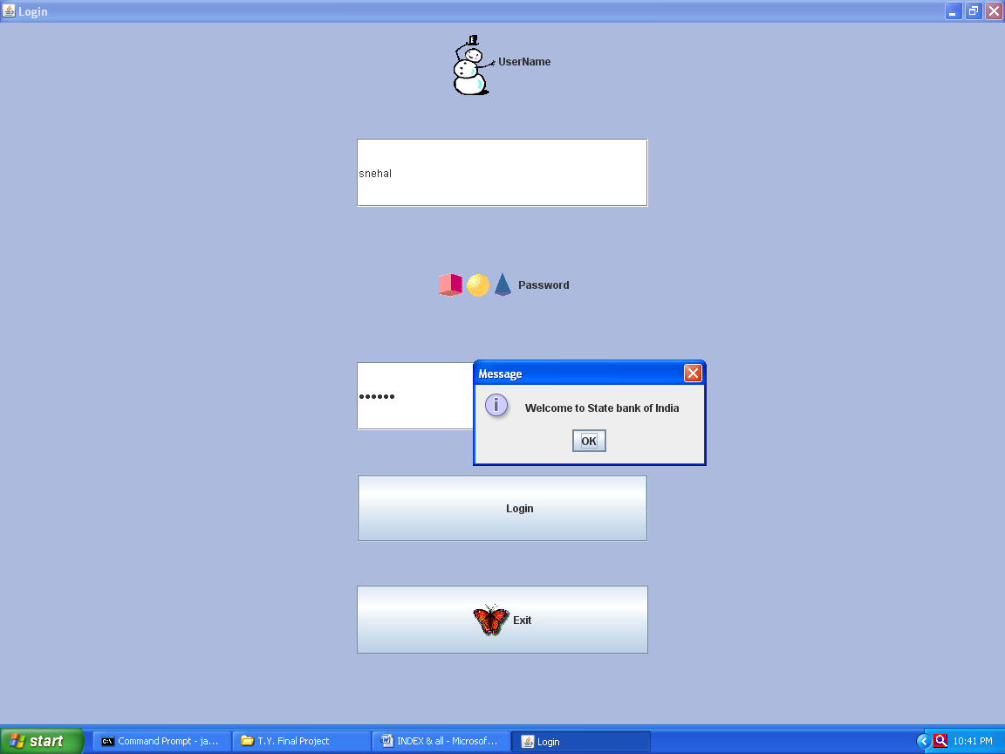

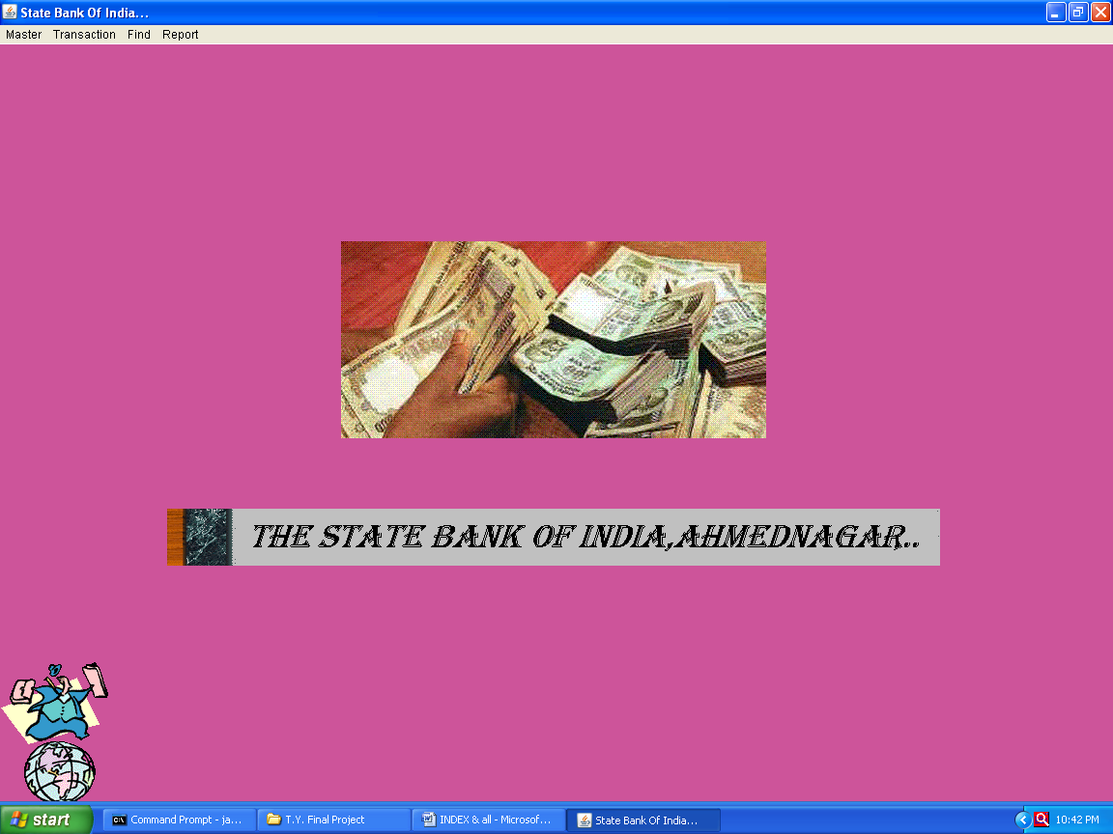

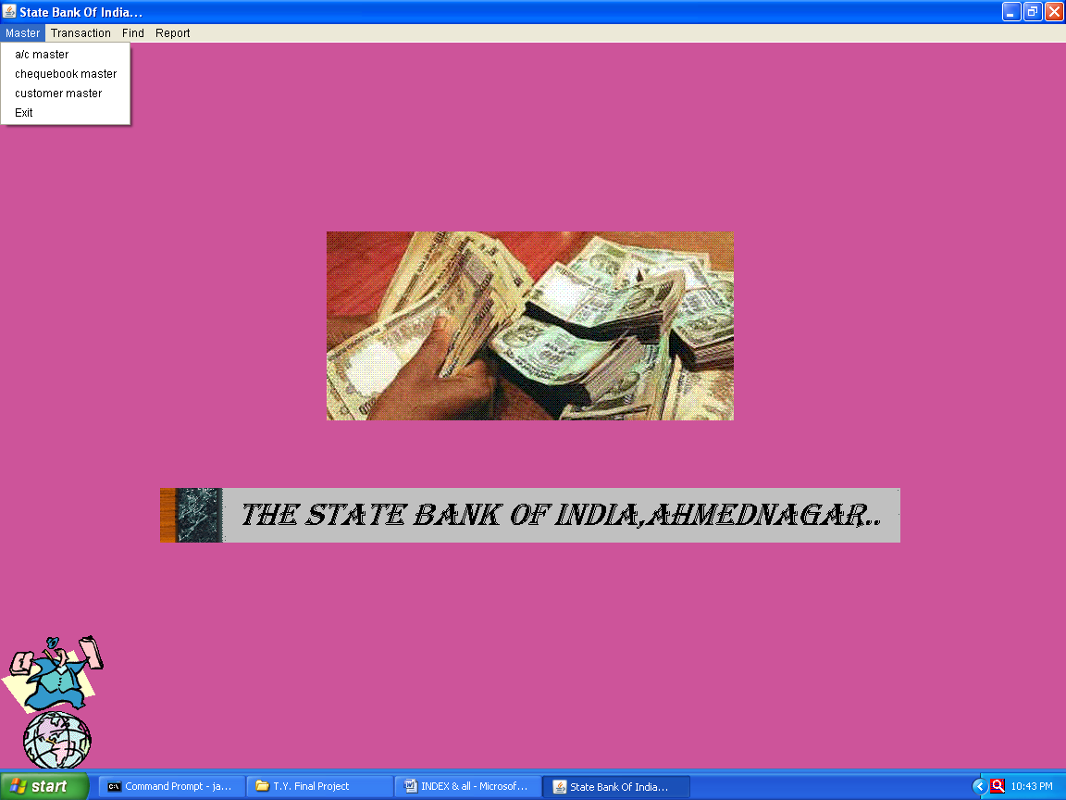

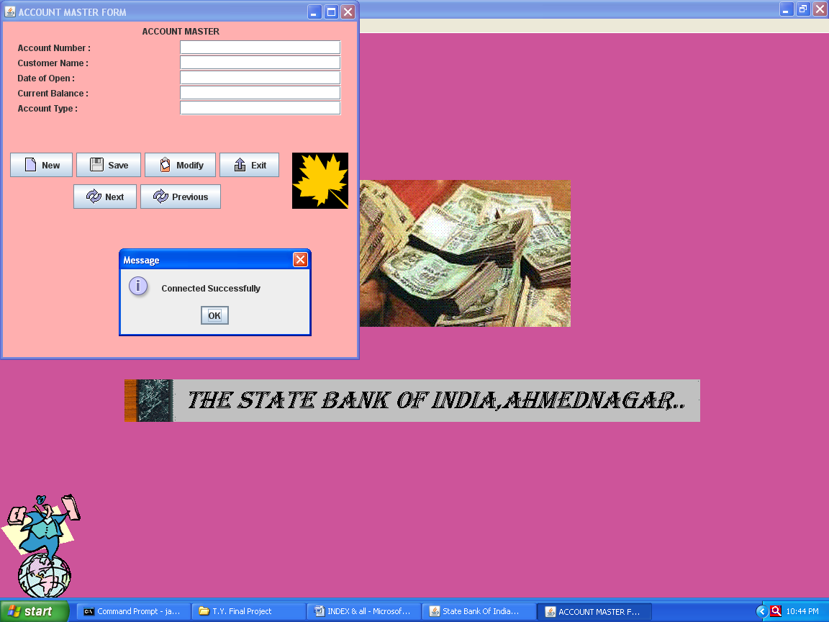

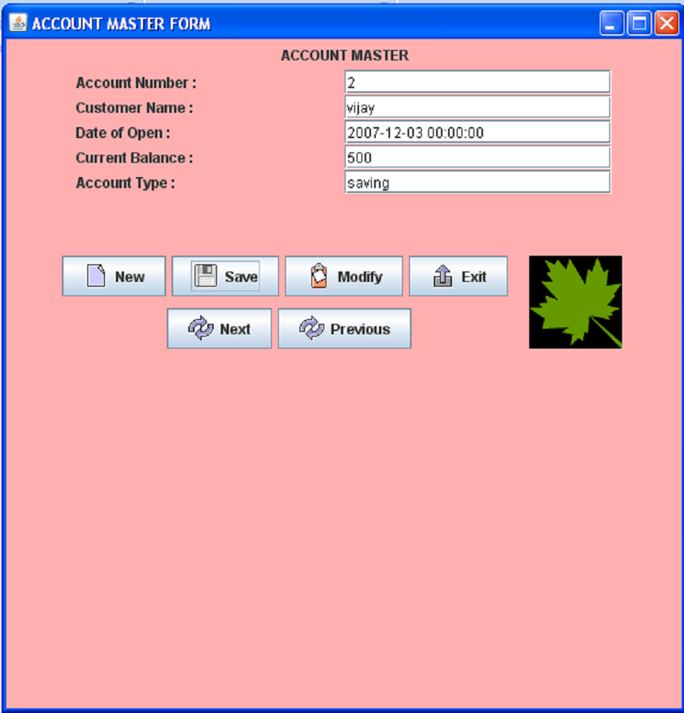

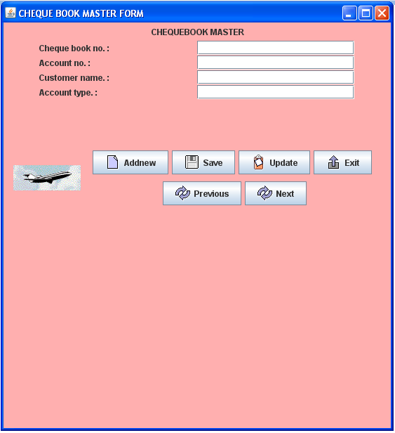

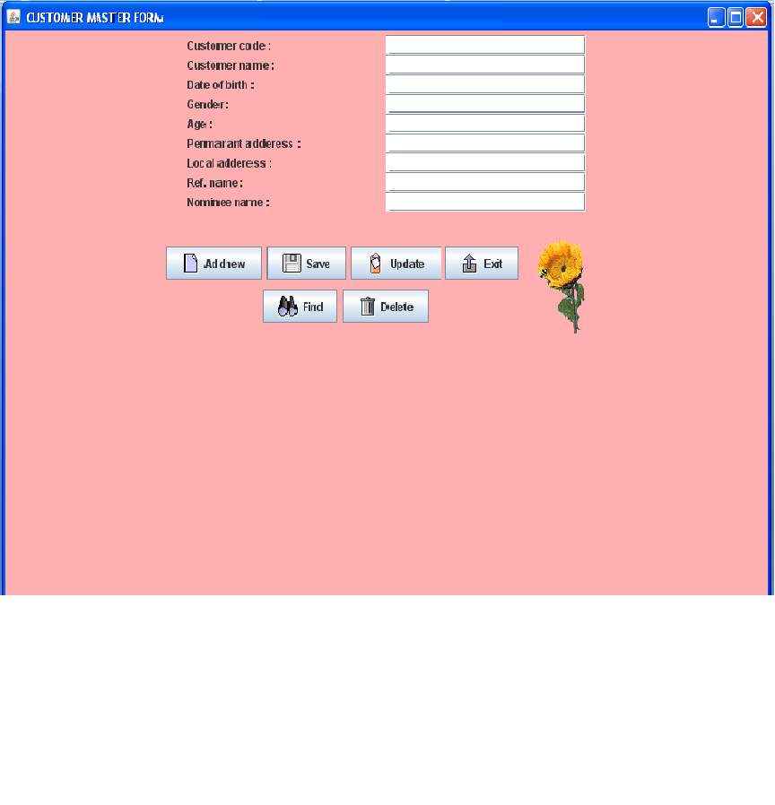

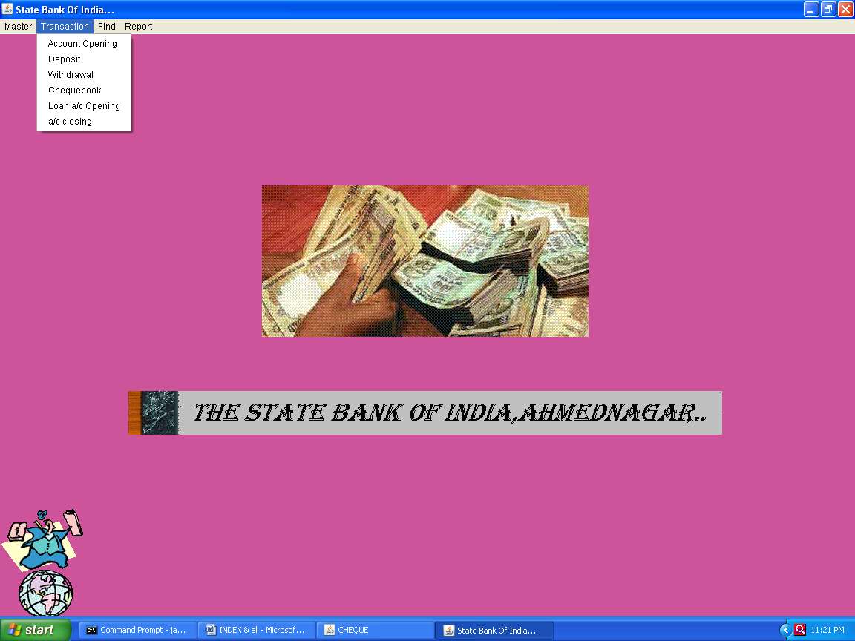

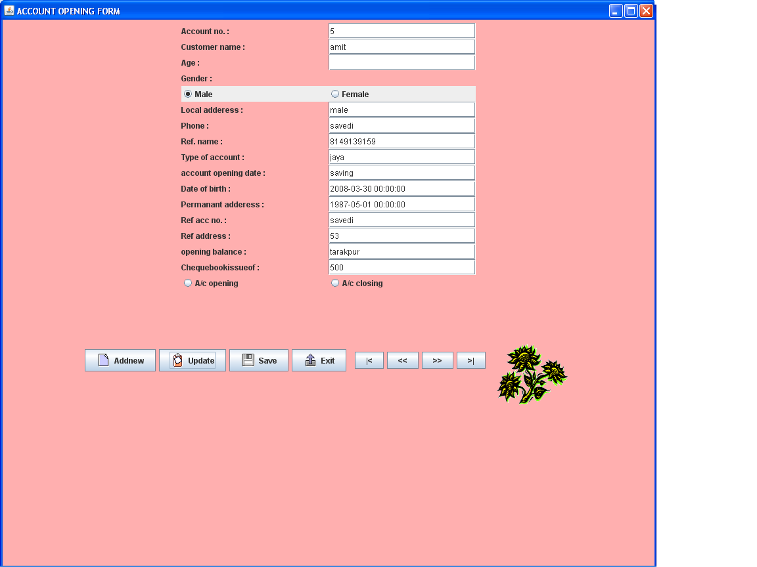

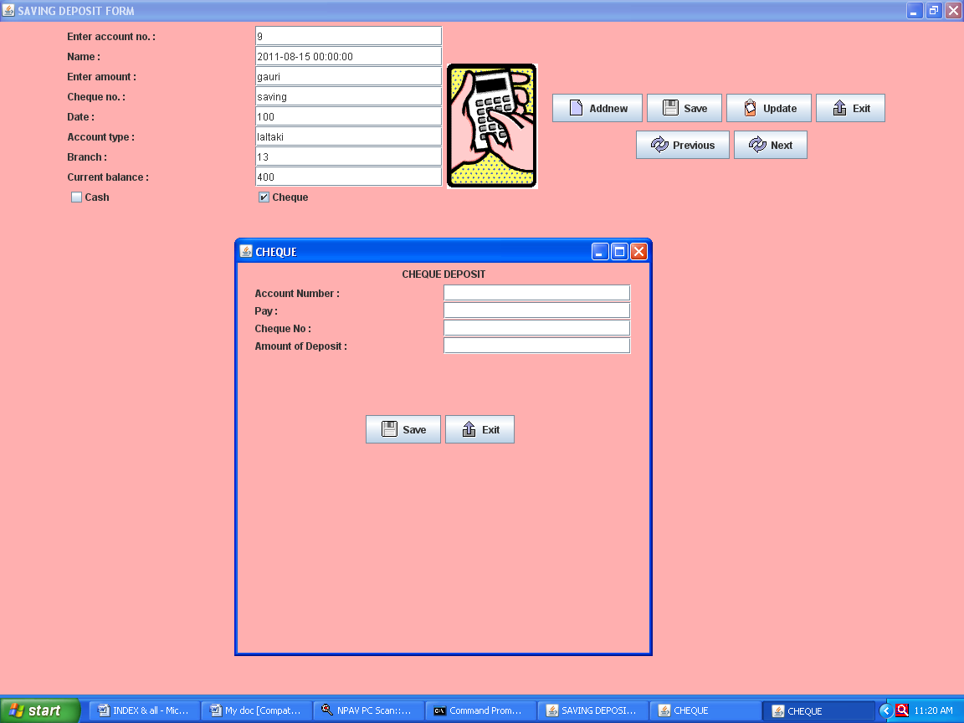

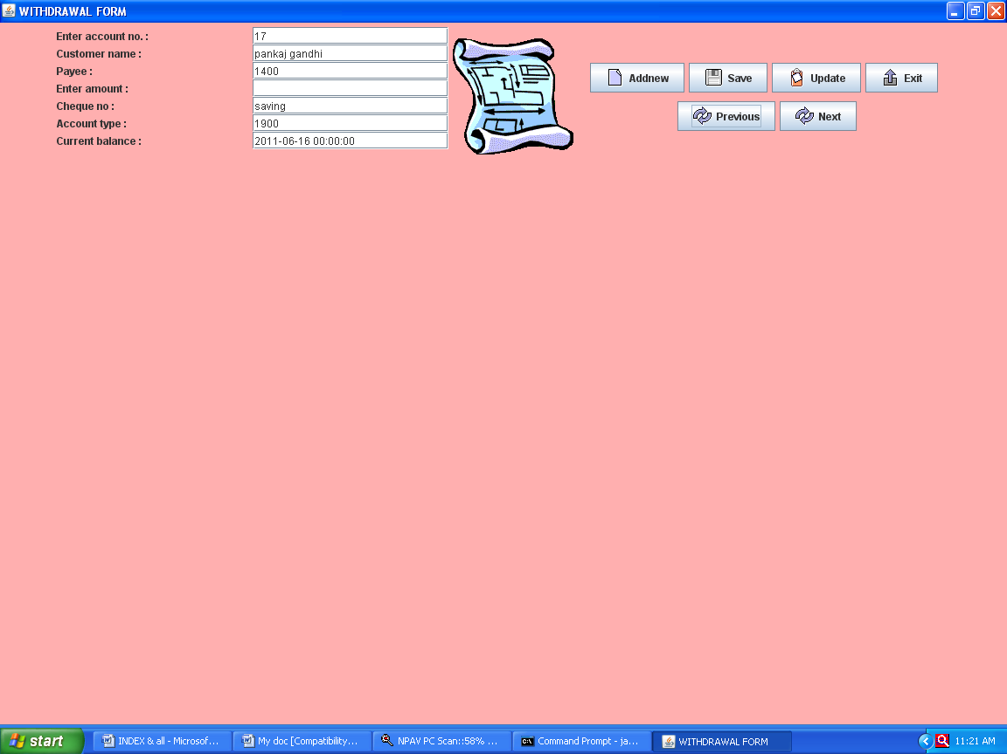

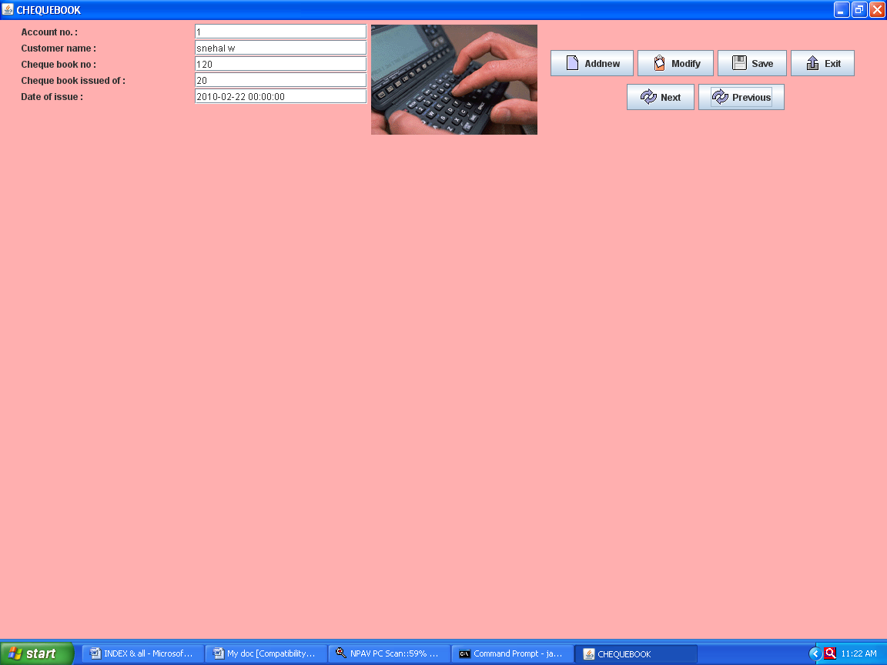

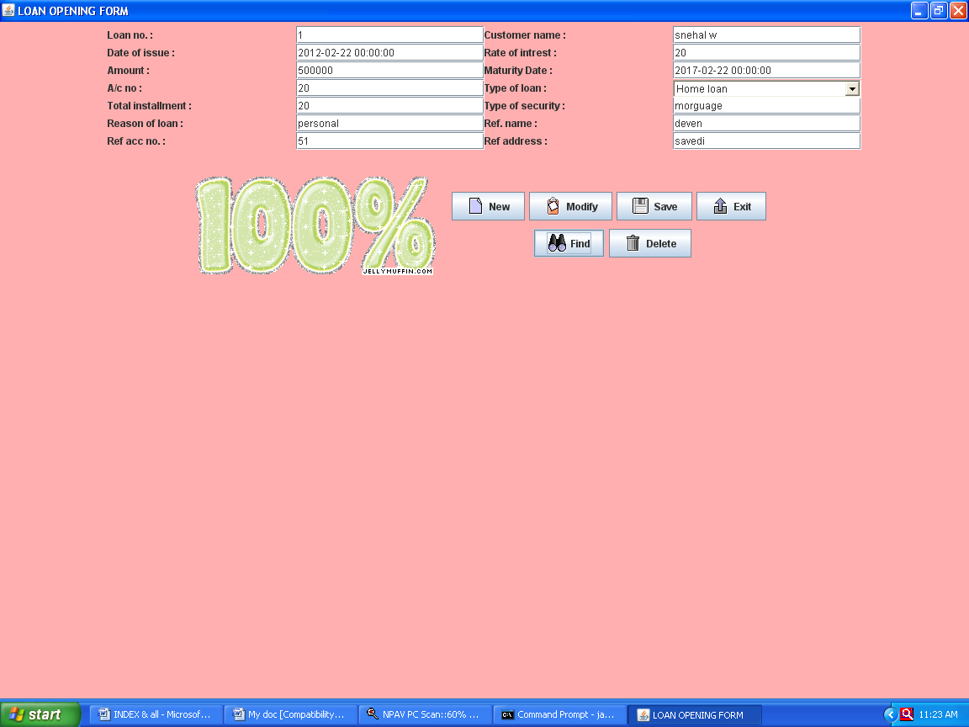

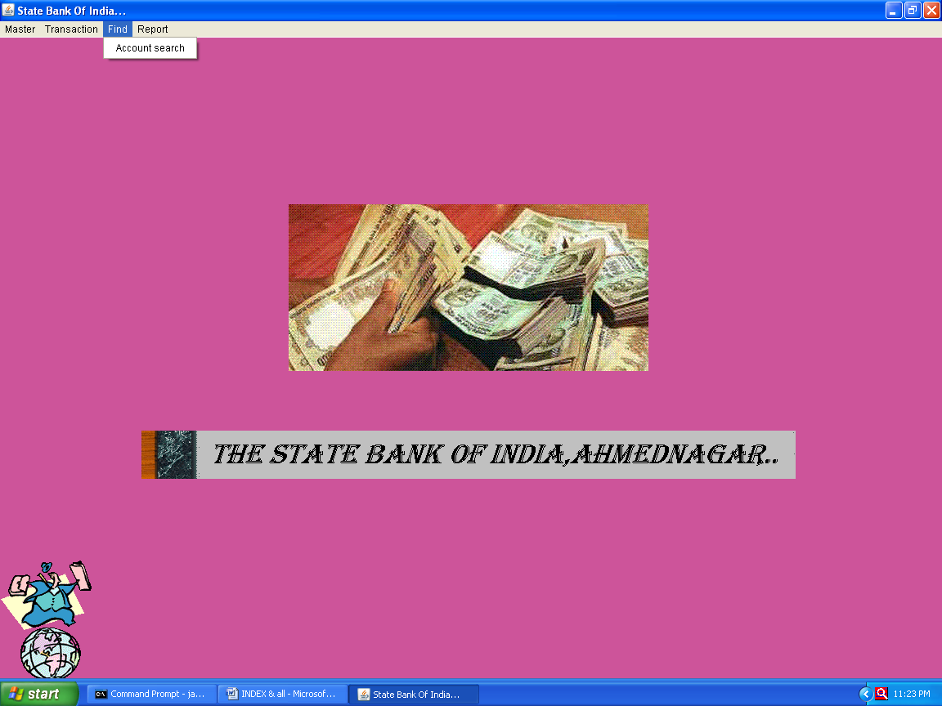

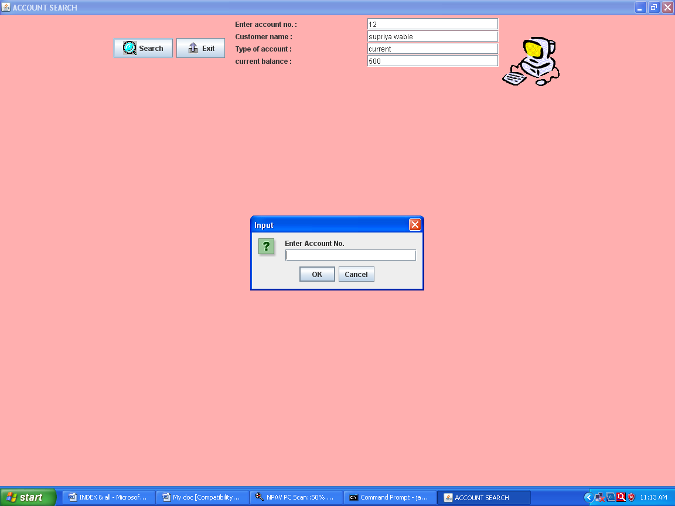

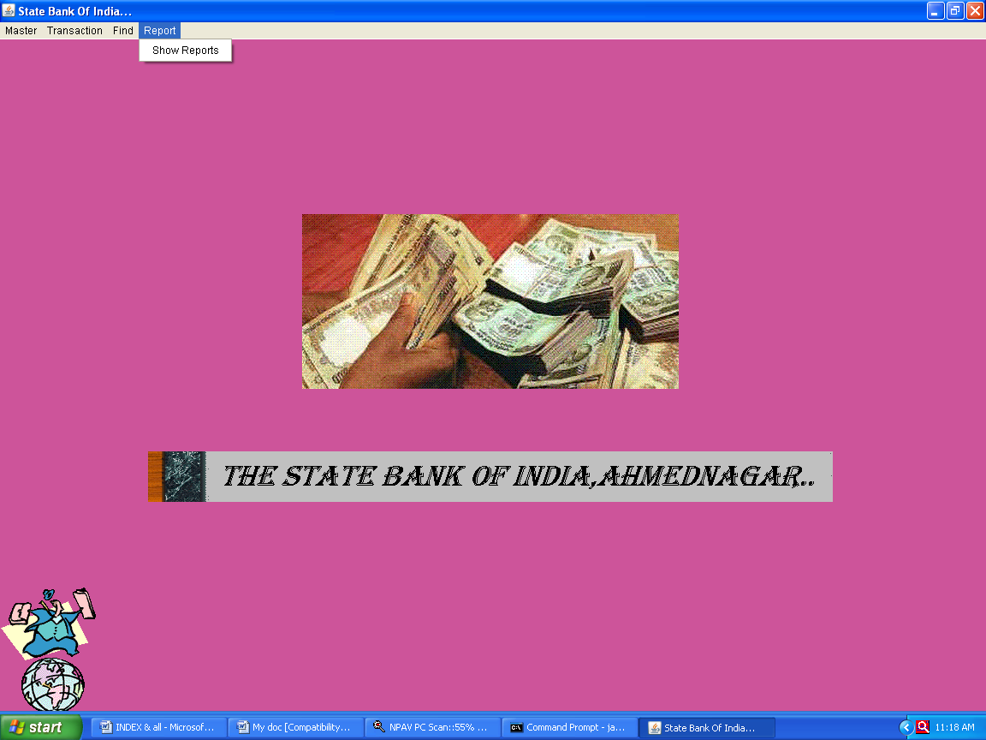

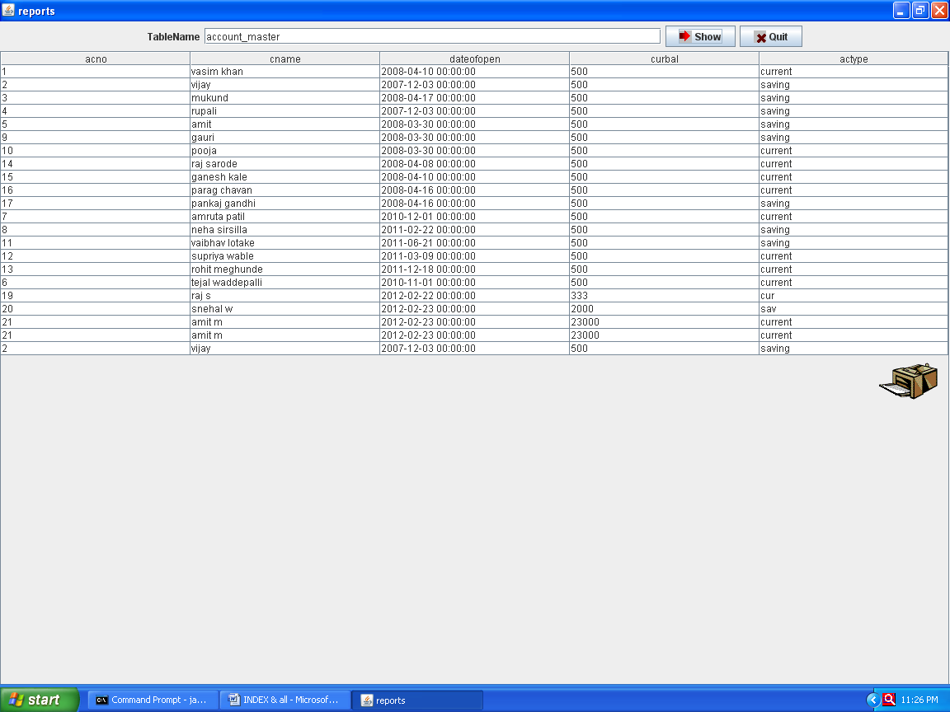

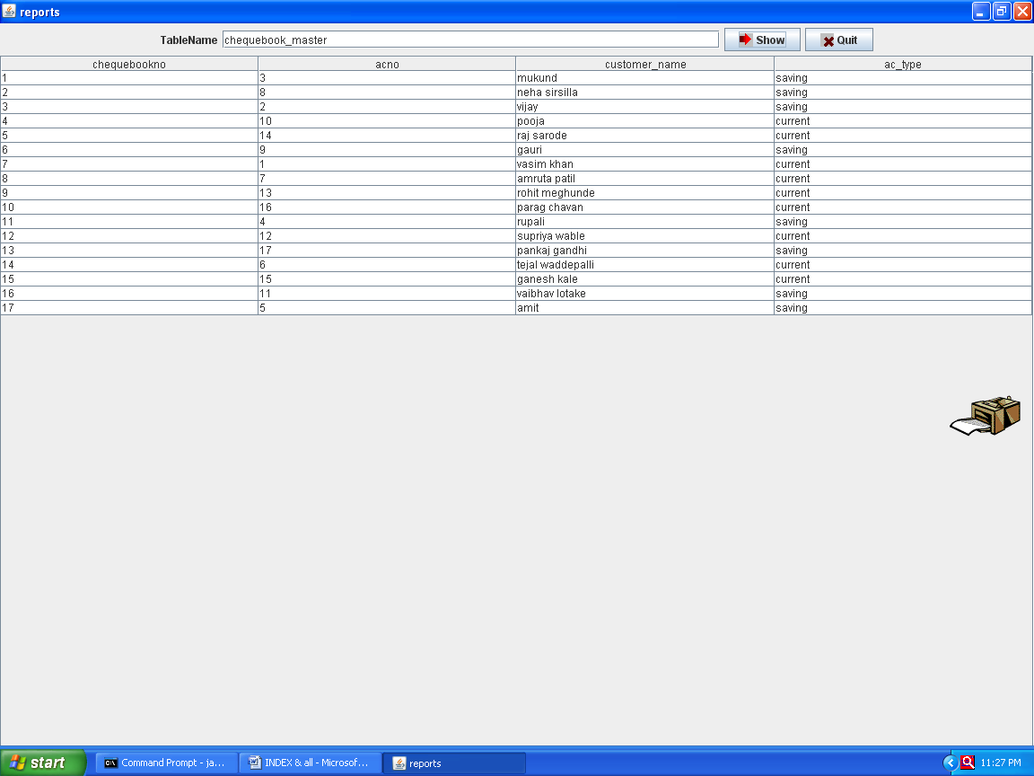

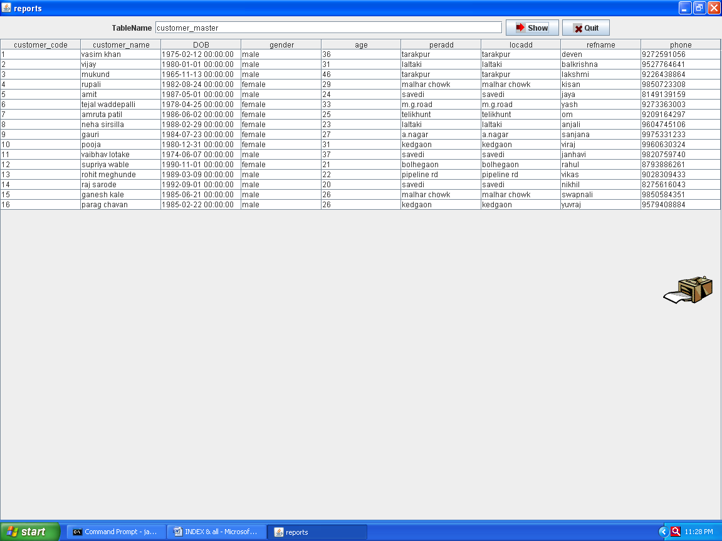

**REPORTS**

| **account_master** | | | | |
| --- | --- | --- | --- | --- |
| **acno** | **cname** | **dateofopen** | **curbal** | **actype** |
| 1 | vasim khan | 4/10/2008 | 500 | current |
| 2 | vijay | 12/3/2007 | 500 | saving |
| 3 | mukund | 4/17/2008 | 500 | saving |
| 4 | rupali | 12/3/2007 | 500 | saving |
| 5 | amit | 3/30/2008 | 500 | saving |
| 9 | gauri | 3/30/2008 | 500 | saving |
| 10 | pooja | 3/30/2008 | 500 | current |
| 14 | raj sarode | 4/8/2008 | 500 | current |
| 15 | ganesh kale | 4/10/2008 | 500 | current |
| 16 | parag chavan | 4/16/2008 | 500 | current |
| 17 | pankaj gandhi | 4/16/2008 | 500 | saving |
| 7 | amruta patil | 12/1/2010 | 500 | current |
| 8 | neha sirsilla | 2/22/2011 | 500 | saving |
| 11 | vaibhav lotake | 6/21/2011 | 500 | saving |
| 12 | supriya wable | 3/9/2011 | 500 | current |
| 13 | rohit meghunde | 12/18/2011 | 500 | current |
| 6 | tejal waddepalli | 11/1/2010 | 500 | current |
| 19 | raj s | 2/22/2012 | 333 | cur |
| 20 | snehal w | 2/23/2012 | 2000 | sav |
| 21 | amit m | 2/23/2012 | 23000 | current |
| 21 | amit m | 2/23/2012 | 23000 | current |

| **chequebook_master** | | | |
| --- | --- | --- | --- |
| **chequebookno** | **acno** | **customer_name** | **ac_type** |
| 1 | 3 | mukund | saving |
| 2 | 8 | neha sirsilla | saving |
| 3 | 2 | vijay | saving |
| 4 | 10 | pooja | current |
| 5 | 14 | raj sarode | current |
| 6 | 9 | gauri | saving |
| 7 | 1 | vasim khan | current |
| 8 | 7 | amruta patil | current |
| 9 | 13 | rohit meghunde | current |
| 10 | 16 | parag chavan | current |
| 11 | 4 | rupali | saving |
| 12 | 12 | supriya wable | current |
| 13 | 17 | pankaj gandhi | saving |
| 14 | 6 | tejal waddepalli | current |
| 15 | 15 | ganesh kale | current |
| 16 | 11 | vaibhav lotake | saving |
| 17 | 5 | amit | saving |

| **customer_master** | | | | | | | | |
| --- | --- | --- | --- | --- | --- | --- | --- | --- |
| **customer_code** | **customer_name** | **DOB** | **gender** | **age** | **peradd** | **locadd** | **refname** | **phone** |
| 1 | vasim khan | 2/12/1975 | male | 36 | tarakpur | tarakpur | deven | 9272591056 |
| 2 | vijay | 1/1/1980 | male | 31 | laltaki | laltaki | balkrishna | 9527764641 |
| 3 | mukund | 11/13/1965 | male | 46 | tarakpur | tarakpur | lakshmi | 9226438864 |
| 4 | rupali | 8/24/1982 | female | 29 | malhar chowk | malhar chowk | kisan | 9850723308 |
| 5 | amit | 5/1/1987 | male | 24 | savedi | savedi | jaya | 8149139159 |
| 6 | tejal waddepalli | 4/25/1978 | female | 33 | m.g.road | m.g.road | yash | 9273363003 |
| 7 | amruta patil | 6/2/1986 | female | 25 | telikhunt | telikhunt | om | 9209164297 |
| 8 | neha sirsilla | 2/29/1988 | female | 23 | laltaki | laltaki | anjali | 9604745106 |
| 9 | gauri | 7/23/1984 | female | 27 | a.nagar | a.nagar | sanjana | 9975331233 |
| 10 | pooja | 12/31/1980 | female | 31 | kedgaon | kedgaon | viraj | 9960630324 |
| 11 | vaibhav lotake | 6/7/1974 | male | 37 | savedi | savedi | janhavi | 9820759740 |
| 12 | supriya wable | 11/1/1990 | female | 21 | bolhegaon | bolhegaon | rahul | 8793886261 |
| 13 | rohit meghunde | 3/9/1989 | male | 22 | pipeline rd | pipeline rd | vikas | 9028309433 |
| 14 | raj sarode | 9/1/1992 | male | 20 | savedi | savedi | nikhil | 8275616043 |
| 15 | ganesh kale | 6/21/1985 | male | 26 | malhar chowk | malhar chowk | swapnali | 9850584351 |
| 16 | parag chavan | 2/22/1985 | male | 26 | kedgaon | kedgaon | yuvraj | 9579408884 |

| **acc_opening** | | | | | | | | | | | | | | |
| --- | --- | --- | --- | --- | --- | --- | --- | --- | --- | --- | --- | --- | --- | --- |
| **acno** | **cname** | **age** | **gender** | **localaddress** | **phone** | **refname** | **typeofacc** | **acopendt** | **DOB** | **peraddress** | **refaccno** | **refaddress** | **openingbal** | **chqissue** |
| 2 | vijay |  | male | laltaki | 9527764641 | balkrishna | saving | 12/3/2007 | 1/1/1980 | laltaki | 51 | savedi | 500 | 50 |
| 4 | rupali |  | female | malhar chowk | 9850723308 | kisan | saving | 12/3/2007 | 8/24/1982 | malhar chowk | 52 | kedgaon | 500 | 20 |
| 5 | amit |  | male | savedi | 8149139159 | jaya | saving | 3/30/2008 | 5/1/1987 | savedi | 53 | tarakpur | 500 | 35 |
| 9 | gauri |  | female | a.nagar | 9975331233 | sanjana | saving a/c | 3/30/2008 | 7/23/1984 | a.nagar | 54 | a.nagar | 500 | 50 |
| 10 | pooja |  | female | kedgaon | 9960630324 | viraj | current a/c | 3/30/2008 | 12/31/1980 | kedgaon | 55 | tarakpur | 500 | 50 |
| 14 | raj sarode |  | male | savedi | 8275616043 | nikhil | current a/c | 4/8/2008 | 9/1/1992 | savedi | 56 | burudgaon | 500 | 30 |
| 1 | vasim khan |  | male | tarakpur | 9272591056 | deven | current a/c | 4/10/2008 | 2/12/1975 | tarakpur | 57 | malhar chowk | 500 | 30 |
| 15 | ganesh kale |  | male | malhar chowk | 9850584351 | swapnali | current a/c | 4/10/2008 | 6/21/1985 | malhar chowk | 58 | a.nagar | 500 | 35 |
| 16 | parag chavan |  | male | kedgaon | 9579408884 | yuvraj | current a/c | 4/16/2008 | 2/22/1985 | kedgaon | 59 | savedi | 500 | 35 |
| 17 | pankaj gandhi |  | male | burudgaon | 9405268968 | malati | saving a/c | 4/17/2008 | 1/25/1989 | burdgaon | 60 | tarakpur | 500 | 40 |
| 3 | mukund |  | male | tarakpur | 9226438864 | lakshmi | saving | 4/17/2008 | 11/13/1965 | tarakpur | 61 | m.g.road | 500 | 50 |
| 6 | tejal waddepalli |  | female | m.g.road | 9273363003 | yash | current | 11/1/2010 | 4/25/1978 | m.g.road | 62 | telikhunt | 500 | 50 |
| 7 | amruta patil |  | female | telikhunt | 9209164297 | om | current | 12/1/2010 | 6/2/1986 | telikhunt | 63 | bolhegaon | 500 | 50 |
| 8 | neha sirsilla |  | female | laltaki | 9604745106 | anjali | saving | 2/22/2011 | 2/29/1988 | laltaki | 64 | pipeline rd | 500 | 35 |
| 11 | vaibhav lotake |  | male | savedi | 9820759740 | janhavi | saving | 6/21/2011 | 6/7/1974 | savedi | 65 | savedi | 500 | 20 |
| 12 | supriya wable |  | female | bolhegaon | 8793886261 | rahul | current | 3/9/2011 | 11/1/1990 | bolhegaon | 66 | a.nagar | 500 | 20 |
| 13 | rohit meghunde |  | male | pipeline rd | 9028309433 | vikas | current | 12/18/2011 | 3/9/1989 | pipeline rd | 67 | kedgaon | 500 | 20 |
| 14 | raj sarode | 20 | male | savedi | 8275616043 | nikhil | current a/c | 4/8/2008 | 9/1/1992 | savedi | 56 | burudgaon | 500 | 30 |
| 20 | deven sunki | 26 | male | savedi | 9028040956 | snehal w | saving | 1/12/2011 | 1/12/1986 | savedi | 3 | savedi | 500 | 20 |

| **deposit** | | | | | | | |
| --- | --- | --- | --- | --- | --- | --- | --- |
| **acno** | **ddate** | **cname** | **acctype** | **amt** | **branch** | **chqno** | **curbal** |
| 9 | 8/15/2011 | gauri | saving | 100 | laltaki | 13 | 400 |
| 12 | 6/8/2011 | supriya wable | current | 300 | savedi | 7 | 200 |
| 7 | 11/11/2011 | amruta patil | current | 400 | laltaki | 15 | 100 |
| 16 | 10/9/2011 | parag chavan | current | 120 | laltaki | 9 | 380 |
| 1 | 3/24/2011 | vasim khan | current | 350 | savedi | 10 | 150 |
| 1 | 3/24/2011 | vasim khan | current | 350 | savedi | 10 | 150 |
| 1 | 3/24/2011 | vasim khan | current | 350 | savedi | 10 | 150 |

| **chequebook** | | | | |
| --- | --- | --- | --- | --- |
| **acno** | **customer_name** | **chequebook_no** | **chequebookissuedof** | **dateofissue** |
| 1 | snehal w | 120 | 20 | 2/22/2010 |
| 2 | supriya wable | 240 | 20 | 3/19/2010 |
| 3 | amruta patil | 11 | 25 | 9/1/2010 |
| 4 | neha sirsilla | 14 | 30 | 1/9/2010 |

| **withdrawl** | | | | | | |
| --- | --- | --- | --- | --- | --- | --- |
| **acno** | **payee** | **amt** | **chqno** | **actype** | **cbalance** | **withdrawaldt** |
| 3 | mukund | 500 |  | saving | 100 | 3/12/2011 |
| 5 | amit | 1000 |  | saving | 1500 | 8/4/2011 |
| 8 | neha sirsilla | 1000 |  | saving | 1500 | 10/31/2011 |
| 10 | pooja | 500 |  | current | 1000 | 4/29/2011 |
| 15 | ganesh kale | 1200 |  | current | 1700 | 11/13/2011 |
| 17 | pankaj gandhi | 1400 |  | saving | 1900 | 6/16/2011 |

| **loan_opening** | | | | | | | | | | | | |
| --- | --- | --- | --- | --- | --- | --- | --- | --- | --- | --- | --- | --- |
| **loan_no** | **customer_name** | **dateofissue** | **rateofint** | **amt** | **maturitydt** | **acno** | **totalinstallment** | **typeofsecurity** | **reasonofloan** | **refname** | **refaccno** | **refaddress** |
| 1 | snehal w | 2/22/2012 | 20 | 500000 | 2/22/2017 | 20 | 20 | morguage | personal | deven | 51 | savedi |

| **cheque** | | | |
| --- | --- | --- | --- |
| **acno** | **pay** | **chqno** | **amt** |
| 1 | jyoti s. | 12 | 5000 |
| 2 | snehal w. | 20 | 15000 |
| 3 | supriya wable | 13 | 12000 |
| 4 | amruta patil | 9 | 10000 |

**5.TESTING PROCEDURE &**

**IMPLEMENTATION PHASE**

**Testing procedure and Implementation phase**

**Prior to my system implementation there is a possibility that finally the implemented system any prove enormous. If under such condition in the circumstances if the system is used, it may very difficult to avoid this confusion it is to have a test run before the final implementation of system.**

**Any system is useful only when it run smoothly there is gives correct tested before it implementation this is possible only when the system is tested before it implementation the daily process. In implementation the problem, which arise are suggestion or requirement.**

**System is tested on the basic of raw data, the result which is then produced by computer with those the manual calculation if it all any different arises then the process is recessed and checked. This where error is found it is alter in this correct found.**

**Again the test is run is done and the if data is correct and if it meet the programmer requirement then its output is again tally with that it manual calculation. Here it found of that both the result matches. Now at this stage user see the system once again. He may suggest some change in the format of the report a pending on requirement of the system. According to user need the change arte made and again there is test run on whole system. Finally when user is satisfied the whole system and the raw data are implemented in system and against the whole process is repeated until the satisfactory result is achieved.**

**A database is maintained for all the different services provide to the patients. Service rates etc are also maintained in database which is taken help of during the bill calculation.**

6.USER MANUAL



**USER MANUAL**

**User manual is a guideline for the user for operating the system. the user given a guideline about the system. It is essential that it should meet the entire requirement and user should give a glimpse to the user manual in order to acquire the sufficient knowledge of the new system so that it becomes easy for him to use it and handle it in a proper manner.**

**The “Bank accounting system” is developed in advance java. The system is developed as per the user requirement that they mentioned at the time of the data collection.**

**The system is very busy to those who have the fundamental knowledge of computer operations and little bit of this user manual. With the appropriate error messages and supporting help make the system easy to handle.**

**The main menu is as below:**

**master, transaction, find, report.**

**In master option all the forms for master entries will appear. In transaction option all the forms foe transaction entries will appear. In report option all the report will appear. As per the need you have to select specific entry form to utilizes like calculation, notepad windows media player, game ets.**

**7.cONSTAINTS & LIMITATIONS**

***Limitations***

**In the proposed system also there are some constraints & limitations, which are given below.**

1. **System cannot one book at a times i.e.means System can test all books details.**
2. **Proper training has to be provided to Car.**
3. **We have no facility to update after the saving Customer information & report in that relative table.**
4. **There is no facility to check the past & current records are same or not.**
5. **The coding system is developed, assuming that length of the codes created is sufficient. It data crossed the limit the system would not be able to support it.**
6. **Due to lack of time we could not offer more facilities.**
7. **The minimum software requirement maintained in the software platform is must else software will not work.**

1. **There can be an external disk error notice by the operating system. In this**

**case reinstallation is the only solution.**

8.cONCLUSION

**conclusion**

**All the beginning of the implementation phase of system. It is being that user are quite attracted towards new computerized system, but when they come to know the miracles of the system they becomes more and more interested and preferred work with computer. But they don’t have sufficient knowledge about computer.**

**This can be eliminated by providing training and testing about fund of computer and its applications. The user gives position response toward new computerized system, because of decrease in their workload. When any system is implemented then user’s satisfiaction gets first preference. The user satisfiaction means real implementation of the system. The user gets satisfies only and only when the required get outputs.**

**The system generates error message whenever required, the validation facilities of the system totally eliminate the change of wrong data entry.**

**A] A commendable features of the project are:-**

1. **User friendly.**
2. **Man hour saving.**
3. **To an extent pays way for paperless office.**
4. **Variety of report generation.**
5. **Property documented.**

**B] key improvement areas and suggestion for further development:-**

**Though the system is very useful for concern organization but it can also be modified. In case of inventory system that is used with computerization but proper modifications it is also possible so the system will be beneficial.**

9.**bibliography**

**BOOKS:**

***Following is the list of books and the tutorial software’s that helped us to create our project.***

***Java complete Reference book***

**....By – Herbert Schield**

***Java programming language***

**....By - *James golfing and David Holmes***

***Pro java Swing***

***….By- John Zukoski***

***Software Engineering***

***…….By- Roger Pressmen***

***Java Black Book***

***……By - E.balgurusamy***

**WEBSITE:-**

[**http://www.Google.com**](http://www.Google.com)

[**http://www.javaprogramming.com**](http://www.javaprogramming.com)

**AHMEDNAGER JILHA MARATHA VIDYA PRASARAK SAMAJ’S**

**New Art’s Commerce & Science College, Ahmednagar**

**Project Report**

**On**



***BANK ACCOUNTING SYSTEM***

**Submitted by**

**Miss.**

***Under the guidance of,***

***Prof.***

***In partial fulfillment for the award of the degree***

***Of***

***MASTER OF COMPUTER SCIENCE***

**UNIVERSITY OF PUNE 2012-2013**